Cut this top row off before you give the sort to pupils!

Different phoemes for y at end of words: ee or igh NB none of the endings
actually sound like a y phoneme at the ends of words
There are some oddballs where the y sounds like short I, in the middle of a word

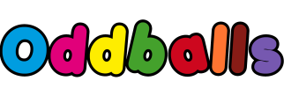 | y like igh | y like ee
fly | greedy | sulky
try | reply | sky
my | fly | fry
cry | dry | by
telly | funny | mummy
daddy | happy | family
baby | lorry | city
heavy | carry | jelly
by | shy | why
qualify | crystal | pyramid
bicycle

